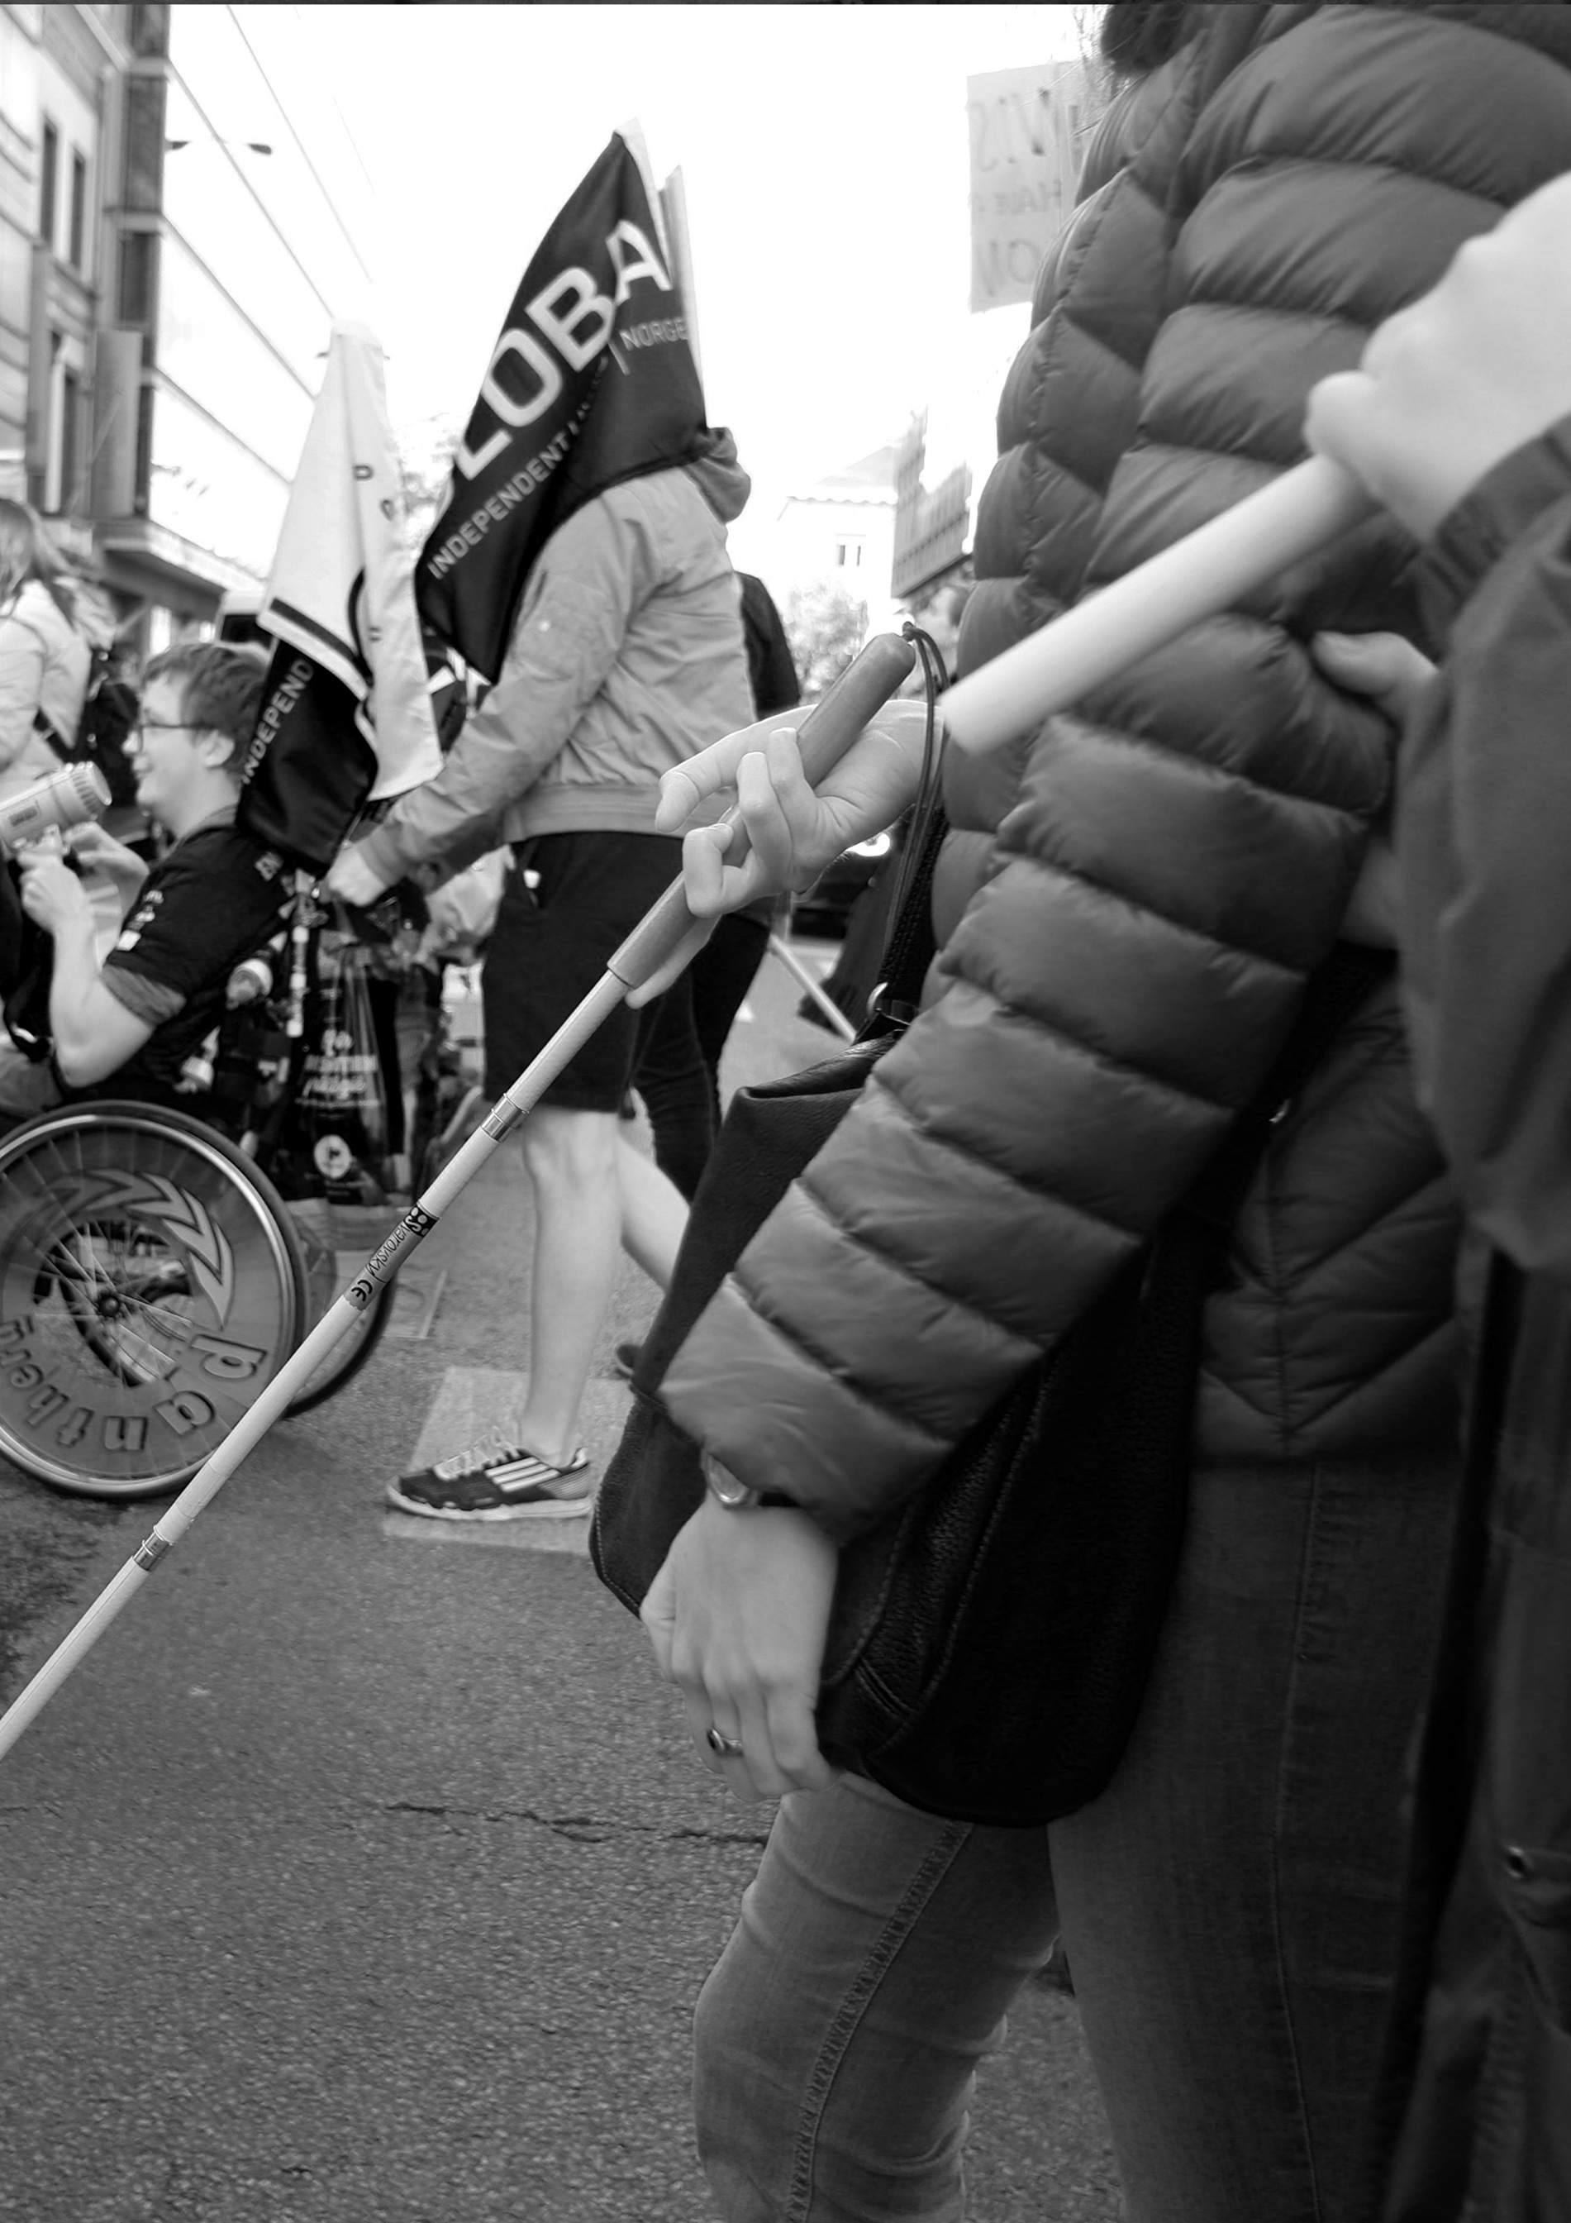

**Freedom Drive Demands:**

**Reclaiming Our Rights NOW!**

**Freedom Drive 2024**

**Freedom Drive Demands: Reclaiming Our Rights NOW!**

**Freedom Drive 2024**

# **“Let us turn articles of the UN CRPD into European Union Directives”**

(Adolf Ratzka)

From the 23rd to the 25th of September 2024, the European Network on Independent Living – ENIL will hold its 11th edition of the Freedom Drive in Brussels. The **Freedom Drive** is one of ENIL’s key campaigns – it has taken place every two years since 2003.

ENIL is a Europe-wide network of disabled people. For us, Independent Living is a process of empowerment and emancipation, enabling equal opportunities, rights and full participation in all aspects of society. We advocate for the complete removal of all barriers restricting the inclusion of disabled people in the community.

One of our main goals is the implementation of the UN Convention on the Rights of Persons with Disabilities (UNCRPD) in the European Union. The UNCRPD promotes full participation, independent living and deinstitutionalisation. The European Union and all 27 Member States ratified the UNCRPD. In the EU, the Convention entered into force in January 2011, and yet independent living is still not a reality for all.

Given that a new European Parliament has been elected and that a new European Commission will come into office, we seek new commitments to end all types of segregation and realise Independent Living for all.

When presenting our demands, it is imperative to highlight the intersectional nature of the barriers faced by disabled people. Disabled women and girls, LGBTQIA+ disabled people, refugees or migrants, or those who belong to an ethnic minority are more severely affected by discrimination or violence and have an even harder time accessing support. Policy solutions must always address the needs of all disabled people, including those belonging to the most disadvantaged societal groups. Support must be ensured regardless of their type of impairment or intersectional identity.

The European Union has trade agreements with most countries in the world and is together with all its Member States the largest donor of development aid worldwide. The EU has an obligation to use its position to promote human rights and the rights of disabled people globally.

The ENIL Freedom Drive demands to the European Union, its member States and other European countries are:

1. **Stop public funding for institutions of any size and segregating services.** Reform all legislation on EU funds and on state aid to ensure financial resources go into community-based services.
2. **Guarantee the right to Independent Living** by setting standards for access to community-based and person-centred services, in compliance with the CRPD. Require adoption of strategies for the expansion of community based and person-centred services in the community and for deinstitutionalisation in all the Member States and through global action.
3. **Recognise supported decision making** in cross-border situations. Do so by subjecting the proposed regulation on the protection of vulnerable adults to a complete overhaul, replacing all paragraphs on the deprivation of legal capacity.
4. **Create social equality** between disabled and non-disabled people and in society in general and combat social exclusion. To that end, ensure equal access to employment, healthcare, social protection, education, all goods and services and housing in the community.
5. **Ensure that the implementation of the UN CRPD is coordinated across all policy areas.** The EU requires the implementation of focal points across policy areas, the establishment of a proper interinstitutional coordination mechanism and a civil society mechanism.

**Freedom Drive Demand 1:**

**Stop public funding for institutions and segregating services**

**We call on the European Union to end investments from EU funding and state aid into segregated settings for disabled people.**

The EU supports investments in social services in the Member States through funding from its seven-year budget. The EU’s Cohesion Policy 2021-2027 introduced conditions to receive funding, including compliance with the EU Charter on Fundamental Rights and the UNCRPD. When the EU introduced its COVID-19 recovery funding, NextGeneration EU, the Recovery and Resilience Facility was established – without any conditionalities.

In this period, we found evidence of investments into segregated settings, and more are planned. Although there is little transparency, we have been alerted repeatedly about the Recovery and Resilience Facility being used to build and refurbish institutions.

Next year, the Commission will present a proposal for its new seven-year budget 2028-2034. We need a new framework that:

1. Strictly prohibits investments into institutions and any other segregated settings, including small group homes, day-care centres, and special schools, and has strong mechanisms to report these investments;
2. Strongly promotes investments into community-based services and support for disabled people, including access to regular housing in the community;
3. Includes disabled people and representative organisations in all the discussions, in a meaningful manner and not as a “tick-box” exercise.

Evidence gathered by ENIL indicates that segregating services such as institutions and sheltered workshops also receive substantial subsidies from the budgets of national and local authorities.[1] The General Block Exemption Regulation (GBER)[2] of the EU makes it possible to support the integration of disabled people into the labour market financially from public budgets. ENIL welcomes this rule.

Unfortunately, the GBER also permits subsidies to sheltered workshops in its article 34, f. Article 34 (f) should be removed from the regulation. It has been shown many times that sheltered workshops are ineffective in enabling a transition to the regular labour market. Such places trap disabled people in an exploitative form of employment. We need to combat discrimination at work so that every disabled person can have a job that pays a fair wage.

According to General Comment No 8 of the Committee on the Rights of Persons with Disabilities, segregated forms of employment of disabled people, such as sheltered workshops, are characterised by at least some of the following elements:

1. The persons with disabilities are segregated away from open, inclusive and accessible employment;
2. The employment is organised around certain specific activities that persons with disabilities are deemed to be able to carry out;
3. The medical and rehabilitation approaches to disability are focused on and emphasised;
4. The transition to the open labour market is not effectively promoted;
5. The persons with disabilities do not receive equal remuneration for work of equal value;
6. The persons with disabilities are not renumerated for their work on an equal basis with others;
7. The persons with disabilities do not have regular employment contracts and are therefore not covered by social security schemes.

GBER should allow authorities to provide financial support to employment ventures such as companies, cooperatives and social enterprises that are managed and led by persons with disabilities, including those that are jointly owned and democratically controlled, if they provide just and favourable conditions of work on an equal basis with others.

**Freedom Drive Demand 2:**

**Guarantee the right to Independent Living**

**We call on the European Union to adopt legislation, setting standards for the access to community-based and person-centred services for all disabled people.**

The legislation should oblige Member States to adopt strategies for the expansion of community-based and person-centred services and for deinstitutionalisation. Such strategies should align with the CRPD and the Guidelines on Deinstitutionalisation, including in Emergencies. They must from the beginning involve disabled people meaningfully and need to be based on data, indicating the capacity increase of services per year and the yearly reductions of places in institutions. More detailed guidance on how to draft strategies on deinstitutionalisation can be found in General Comment No. 5 and the above-mentioned Guidelines.

Among the most important services to be offered in the community is personal assistance, which is a key tool for Independent Living. Personal assistance is a one-on-one support service, where one or several persons support the disabled person for as many hours during the day as needed. It is a personalised needs-based service, meaning that the beneficiary receives support from as many assistants as needed, for as many hours during the day as needed and with any task required. Personal assistants support the disabled person in the home, in educational settings, at work or during leisure activities or wherever is needed. It is essential that recipients have the right to control the service and select, recruit, train and supervise their assistants. Any legislation should state that the funding needed to purchase assistance needs to be disbursed directly to the recipients.

Strategies on deinstitutionalisation need to state clearly that all settings that share any of the following elements need to be closed, in line with the General Comment 5:

* Obligatory sharing of assistants;
* No control over who provides the assistance;
* Isolation and segregation from community;
* Lack of control over day-to-day decisions;
* Lack of choice over whom to live with coupled with rigidity of routine, identical activities for the group and paternalistic approach and supervision;
* Housing and support provided by the same provider.

Research, extensive feedback from disabled people and the monitoring of providers indicate that deinstitutionalisation is not making progress in the EU. In 2007, at least 1,2 million disabled people were estimated to be confined to institutions. In 2020, new research found that at least 1,4 million disabled people live in institutions.[3] The ableist view that disabled people are happy in institutions or that some simply need institutions is becoming more prevalent.

The General Comment 5 and the 2022 Guidelines on Deinstitutionalisation, including in Emergencies, acknowledge that institutionalisation is a discriminatory practice.

There are provisions in the treaties providing the competence to legislate against discrimination of disabled people. Article 19 of the Treaty on the Functioning of the EU allows the Council to take action to combat discrimination “based on sex, racial or ethnic origin, religion or belief, disability, age or sexual orientation”. Article 26 of the EU Charter of Fundamental Rights grants disabled people the right to benefit from measures designed to ensure their independence, social and occupational integration and life of the community.

**Freedom Drive Demand 3:**

**Recognise supported decision-making**

**We call for** **a European Union regulation on supported decision-making**.

The EU institutions are in the process of discussing a proposal for a regulation on the jurisdiction, applicable law, recognition and enforcement of measures and cooperation **in matters relating to the protection of adults** whichproposes to recognise deprivations of legal capacity, guardianship regimes and placements in institutions across borders. The draft legislation also proposes the introduction of registers of disabled people who are under measures of deprivation of legal capacity in each EU Member State. It is proposed that said registers shall provide details of the deprivation measures taken against this person and be available to authorities on each EU country.

We are asking for all references to the concept of legal capacity to be removed from the text and replaced by provisions on supported decision-making. A European Union regulation on supported decision-making would give this concept additional legal legitimacy and speed up reforms. Only 6 EU Member States have nearly abolished restrictions of legal capacity.[4]

We are asking for the articles 45, 46 and 47 proposing the introduction of registers to be removed.

If it should not be possible, to substantially change the regulation, we strongly advocate for it to be cancelled altogether.

Article 12 of the UN CRPD forbids restrictions of legal capacity on the grounds of disability. General Comment No. 1 explains this article in detail. Deprivations of legal capacity often lead to institutionalisation, thereby infringing on Article 19 of the UN CRPD on Independent Living.

Article 22 of the UN CRPD grant disabled people the right to privacy. Article 8(1) of the Charter of Fundamental Rights of the EU and Article 16(1) of the Treaty on the Functioning of the European Union give every EU citizen the right to the protection of personal data concerning him or her”.

The purpose of decision-making support for disabled people is to help exercise legal capacity on an equal basis with others and to ensure that everyone can enjoy their right to self-determination. In substituted decision-making, a person who is assumed to have impaired decision-making skills, has their legal capacity removed. A legal guardian is appointed who is tasked to take decisions on the disabled person’s behalf, according to the person’s best interest. Guardians have the power to institutionalise people under their care or order other coercive measures. Substituted decision-making can thus have terrible consequences for the people affected.

Supported decision-making recognises that everyone has a will and can be the main actor in their own lives. In supported decision-making, the person receiving support retains their legal capacity and receives help to act according to their own will and preferences. Restrictions of legal capacity on the grounds of disability are not possible. Decision-support must always be voluntary. A disabled person who needs support in exercising their legal capacity may request this and have decision-support persons of their choice appointed. The decision-support can be terminated at any point if that is the wish of the decision-maker.

**Freedom Drive Demand 4:**

**Create Social Equality**

**We call for an EU social inclusion package for disabled people, involving a revision of the Directive on equal treatment in employment and occupation, and guidelines on the provision of income security and housing.**

The employment rate of disabled people has not improved significantly since 2010.[5] There are numerous accounts of disabled people being denied work or losing their jobs because of their disability. Disabled people who do not have access to work, do not always receive income replacement payments that compensate for the risk of poverty. Access to adequate housing can be very challenging. Poverty is a leading cause of institutionalisation.

The Employment equality directive requires various additions, including:

1. Adding all relevant provisions provided by General Comment No. 8
2. The recognition that sheltered workshops are a form of discrimination as well as a definition of this form of employment
3. An obligation for employers to provide equal opportunities and equal remuneration for work of equal value
4. Provisions for enforcement measures that deter employers from any acts of discrimination

To date, there are no EU guidelines for member states on how to reduce the risk of poverty of disabled people. To make sure disabled people are not additionally affected by poverty, Member States should:

1. Provide monthly income replacement benefits that allow for an adequate standard of living, if the person is prevented from working due to discrimination or the nature of their impairment.
2. Provide a monthly inclusion benefit that covers all the extra costs of disability. This benefit needs to be provided independently from the employment status.
3. Disabled people also need access to reasonable accommodations, which must be financed by the public purse. Financing for reasonable accommodations has to be provided independently from the employment status.
4. Adopt housing strategies in co-production with disabled people and their representative organisations.
5. Ensure that disability is defined according to Article 1 of the CRPD and the General Comment 7, in the context of housing policies. This would allow recognition of disability status of all groups of disabled people including those with chronic illnesses, mental health issues/ psychosocial impairments, etc.
6. To improve access to housing, the EU should promote the expansion of social and non-profit housing.[6] Social housing is typically provided and run by public authorities. In some countries it is available to people without or with a low income. In other countries people with a medium income are also eligible. Under non-profit housing, entities like foundations, associations or companies that rent out houses or apartments below market prices are exempt from corporate, trade, property and land transfer taxation. Non-profit housing can be effective in combating dysfunctional market mechanisms that make housing unaffordable. In order to prevent social housing from becoming segregated or turning into ghettos, it is important that it is of good quality and that it is not concentrated in a specific area of the city.

ENIL also calls for the adoption of an ambitious anti-discrimination directive on implementing the principle of equal treatment between persons irrespective of religion or belief, disability, age or sexual orientation that extends beyond the area of employment to all other spheres of life. The proposed legislation intends to ban discrimination when accessing social protection, healthcare, education and goods and services, including housing. Before it can be adopted, the provision against discrimination needs to be strengthened significantly.

**Freedom Drive Demand 5:**

**Reform structures and processes that coordinate the implementation of the UN CRPD**

**We call for the designation of focal points in each European Union institution, agency and body, for the establishment of an interinstitutional coordination mechanism and the introduction of a civil society participation mechanism.**

As state party to the UN CRPD, the EU must actively promote its implementation in all its policy initiatives. Article 33 of the Convention calls on state parties to designate “one or more focal points within government for matters relating to the implementation of the Convention” and to “give due consideration to the establishment or designation of a coordination mechanism within government to facilitate related action in different sectors and at different levels.”

Articles 4, 2 and 33 of the CRPD require close and active involvement of disabled people through their representative organisations.

The Committee on the Rights of Persons with Disabilities recommended “that the European Union consider the establishment of an interinstitutional coordination mechanism and the designation of focal points in each European Union institution, agency and body.”

The EU currently only has one focal point, the Directorate for Employment and Social Affairs within the European Commission. The UN CRPD Committee underlined the importance to “establish focal points on disability across all policy areas”.

There are three active coordination mechanisms, the Working Party on Human Rights of the EU Council (COHOM), the Disability Platform of the European Commission and Commission Inter Service Group on Disability of the European Commission. There is no overarching coordination mechanism, bringing representatives of all EU bodies together.

While an independent monitoring mechanism exists (consisting of the European Parliament, the Fundamental Rights Agency, the European Ombudsman and the European Disability Forum), there is no civil society mechanism in the sense of article 4(2) of the UN CRPD.

This document does not elaborate the various concepts in detail. If you are looking for detailed recommendations on how to organise deinstitutionalisation, personal assistance or peer support, please consult the following publications:

ENIL Briefing on the Use of EU Funds for Independent Living. <https://enil.eu/wp-content/uploads/2023/12/ENIL-Briefing-on-EU-Funds-2021-2027.pdf>

ENIL Proposal to the Framework on Social Services of Excellence. <https://enil.eu/wp-content/uploads/2024/03/ENIL-Proposal_SoSe-of-Excellence_FINAL-Version.pdf>

ENIL Proposal to the Guidance to Member States on Independent Living. <https://enil.eu/wp-content/uploads/2023/05/ENIL_Proposal-to-the-Guidance-on-Independent-Living.pdf>

ENIL Manifesto to the European Elections 2024. <https://enil.eu/campaigns/the-enil-manifesto-to-the-european-elections-and-the-legislative-period-2024-2029/>

Myth Buster on Personal Assistance. <https://enil.eu/wp-content/uploads/2023/06/Myths-Buster_Personal-assistance_web_low-res-1.pdf>

Myth Buster on Independent Living. <https://enil.eu/wp-content/uploads/2022/03/Myths-Buster-final-spread-A3-WEB.pdf>

**About the European Network on Independent Living**

The European Network on Independent Living (ENIL) is a Europe-wide network of disabled people, with members throughout Europe. ENIL is a forum for all disabled people, Independent Living organisations and their non-disabled allies on the issues of Independent Living. ENIL represents the disability movement for human rights and social inclusion based on solidarity, peer support, deinstitutionalisation, democracy, self-representation, cross disability and self-determination. For more information, see: [www.enil.eu](http://www.enil.eu).

**Contact us**

European Network on Independent Living (ENIL)

6th Floor – Mundo J

Rue de l’Industrie 10

1000 Brussels

Belgium

E-mail: [secretariat@enil.eu](mailto:secretariat@enil.eu)

[www.enil.eu](http://www.enil.eu)

Co-funded by the European Union. Views and opinions expressed are however those of the author(s) only and do not necessarily reflect those of the European Union or the European Commission. Neither the European Union nor the granting authority can be held responsible for them.

1. Comp. <https://enil.eu/enil-case-study-finds-state-aid-to-be-important-in-funding-institutions/>; <https://www.kassel.de/aktuelles/aktuelle-meldungen/foerdermittelbescheid.php>
2. <https://eur-lex.europa.eu/legal-content/EN/ALL/?uri=CELEX:02014R0651-20230701>
3. Comp. Beadle-Brown & Co. 2007, <https://research.kent.ac.uk/tizard/2019/06/11/deinstitutionalisation-and-community-living-outcomes-and-costs/>, and Siska & Co. 2020, <https://deinstitutionalisationdotcom.files.wordpress.com/2020/05/eeg-di-report-2020-1.pdf>
4. <https://www.edf-feph.org/publications/executive-summary-edf-human-rights-report-on-legal-capacity-personal-choice-and-control/>
5. According to the European Disability Strategy 2010-2020, in 2010, the employment rate of disabled people stood at 50%, compared to 70% of non-disabled people. A decade later, in 2021, the employment rate of disabled people stood at 50,6%, while the employment rate of non-disabled people increased to 74,8%.
6. <https://www.bmwsb.bund.de/SharedDocs/pressemitteilungen/Webs/BMWSB/DE/2024/06/NWG.html>