What will happen during the Freedom Drive?

Sunday

People arrive in Brussels for the Freedom Drive.

The Board of ENIL has a meeting.

Another Board of ENIL made of young people has a meeting.

Monday

First, you register.

This means ENIL knows you are there to participate
in the Freedom Drive.

There is also some coffee.

Then, workshops start.

Workshops are events where you can learn something
together with other people.

There are many different workshops.

You can choose the ones you like best.

One workshop is about supported decision making.

Supported decision making means that someone helps you understand
what you have to decide on.

They also helps you understand
what are the different things you can choose from.

Then, you decide on your own.

The other workshop on how disabled people’s organisations
can help each other in different countries.

Disabled people’s organisations are organisations
led by disabled people.

These two workshops take place at the same time.

You can choose which one you want to go to.

After the workshop, you have lunch with a sandwich.

After lunch, there are two more workshops.

One workshop is about ableism.

Ableism is when people without disabilities treat disabled people
in a different way from others.

The other workshop is on how the European Union
can help with independent living in your country.

These two workshops take place at the same time.

You can choose which one you want to go to.

After the workshops, there is a coffee break.

After the coffee break, there are three more workshops.

One workshop is about how to create centres for independent living.

The second workshop is about how countries
joining the European Union have to respect disabled people’s rights.

The third workshop is on what young people can do
to help change things for disabled people.

These workshops take place at the same time.

You can choose which one you want to go to.

During this day there will also be an art workshop.

During the art workshop, you can create banners
for the Freedom Drive protest.

You can choose if you want to go to the art workshop
instead of one of the other workshops.

In the evening, there is a Youth Cafè.

A Youth Cafè is an event where you can meet young people
from the Freedom Drive.

Tuesday

In the morning, there is a protest.

During the protest, we walk around Brussels and go to different buildings
where the European Union makes decisions.

After the protest, we go to the European Parliament.

The European Parliament is a place where some people
make important decisions for people living in the European Union.

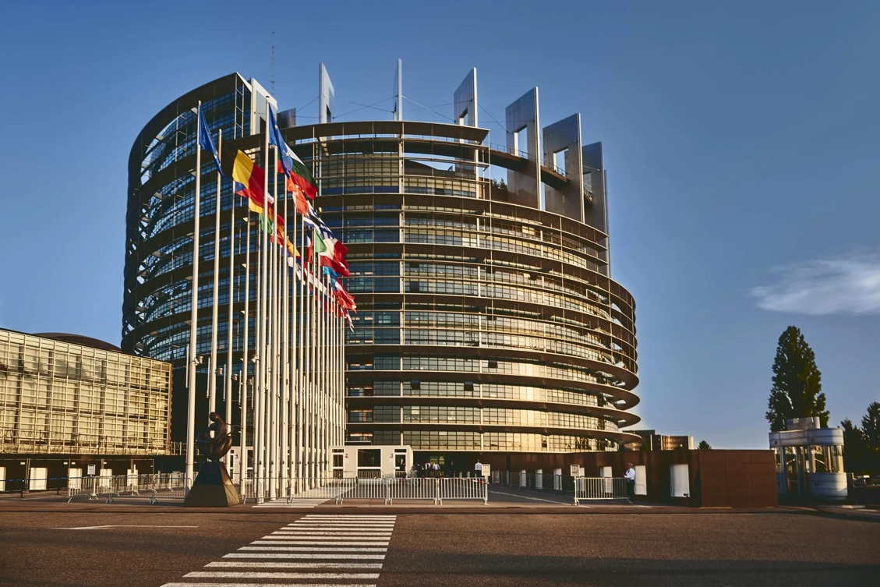

At the European Parliament, there is a meeting.

During this meeting, we explain people who make decisions
in the European Union what we want them to do for disabled people.

In the evening, there is a dinner party.

During this party, we celebrate ENIL’s birthday.

Wednesday

On Wednesday, there is a conference on independent living.

Independent living is when you can decide
everything about your life and do what others do.

During the conference, many people talk about different topics.

First, people talk about deinstitutionalisation.

Deinstitutionalisation means closing institutions.

Institutions are places where disabled people live all together
and cannot choose for themselves.

With deinstitutionalisation, people who lived in institutions
can move to independent living.

After this, we have lunch.

After lunch, other people talk about personal assistance.

Personal assistance is when someone helps you with tasks
such as cooking, getting dressed, travelling etc.

After this workshop, there is a coffee break.

After the coffee break, people talk about how we can help each other, so everyone can live in the community.

